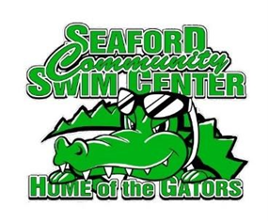

Pool Manager Job Description

Job Overview:
Pool Manager will perform professional duties to ensure the successful running of the Seaford Community Swim Center. Responsibilities include but are not limited to enforcing policies and procedures, which ensure efficient and effective operation of pool facilities including personnel management and training. Duties involve all swimming pool operations, including first aid, rotations, scheduling for staff, public relations, janitorial duties, limited pool maintenance including daily chemical analysis/testing, pool cleaning, cleaning of bathrooms & concession stand area, swim lessons, and all other duties as necessary or required. This employee should have excellent organizational, communication, and public relation skills. This is a working supervisory position requiring some weekend and holiday work.

Responsibilities and Duties:
• Prepares all work schedules and daily job tasks for employees and make sure there is a manager or head lifeguard on duty at all times.
• Assists in the hiring and training of lifeguards.
• Responsible for pool chemistry and communication with the Pool Qualified Operator.
• Handles deposits and reconcile inventory of concessions.
• Purchases and stock concession stand.
• Ensures proper operation of all pool equipment.
• Ensures all guards are maintaining a clean facility to include pool deck, restrooms, and outside of facility.
• Maintains positive relations with the patrons of the pool.
• Enforces all pool rules strictly.
• Documents and report all disciplinary problems/lack of work of lifeguards and report them to the Board of Directors.
• Maintains communication with all employees and set a positive example.
• Reports any problems with the pool or its equipment to the Board immediately.
• Maintains contact with contracted pool technicians to ensure all equipment is working properly.
• Ensures all first aid equipment is stocked and functional.
• Holds/conducts monthly (more if needed) meetings with all lifeguards/employees.
• Oversees the scheduling of pool parties and swim lessons.
• Reports to Board and attends board meetings as needed.

Qualifications:
• Must exhibit good communication and interpersonal skills to manage swimming pool employees and customers.
• Knowledge of pool chemicals, chemical testing, and pool cleaning.
- Must be willing to complete the Red Cross CPR certification prior to pool season opening.
- Preference will be given to applicants who complete Lifeguard Certification training prior to pool opening.

Employee Signature:_______________________________________

